Welcome to Botanic Heaven



Live Plants

Lighting

Fertilizer

FAQ

Botanic Heaven is a Calgary Based website that offers a selection of live plants and goods that ship straight to your door! We at Botanic Heaven want to make sure that your plants arrive alive but if any plants arrive DOA we offer a Reship Guarantee. **Click Here** to find out. more.

“ To plant a garden is to believe in tomorrow”

- Audrey Hepburn

Live Plants!

|  |  |  |  |
| --- | --- | --- | --- |
| **Picture** | **Price** | **Name** | **Needs** |
|  | **$29.99** | **Spider Plant** |  |
|  | **$29.99** | **Ficus Bonsai Tree** |  |
|  | **$69.99** | **Monstera Delicioca** |  |
|  | **$49.99** | **Monstera Adansonii** |  |
|  | **$49.99** | **ZZ Raven** |  |
|  | **$49.99** | **Golden Pothos** |  |
|  | **$23.99** | **Marble Pothos** |  |
|  | **$14.99** | **Birds of paradise** |  |

|  |
| --- |
| **What should you do when you get your new plants?**   1. **We recommend taking your plants out of the box right away (you new plants are excited to meet you!)** 2. **Unwrap your plant carefully very carefully (including the tapes holding the dirt down, let a girl breath!)** 3. **Your plant may look a little droopy ☹ but don’t despair, your new babies are just fine! Put em in a warm bright window and add a little water!** 4. **Send us a review of how much you love your plant! We want to make sure to meet the needs of our clients, if any problems arise please don’t hesitate to contact out support team at botanicheaven@plantmail.com** |

Lighting!

**Why Grow Lights?**

Not everyone that loves plants can have huge windows with tons of light coming through. One product that can help plants grown their fullest are plant lights, with plant lights it doesn’t matter how much sun you’re getting from the outdoors. Anyone can successfully grow even the pickiest of plants with a grow light!

|  |  |  |
| --- | --- | --- |
| Light | Price | Description |
|  | 69.99 |  |
|  | 29.99 |  |

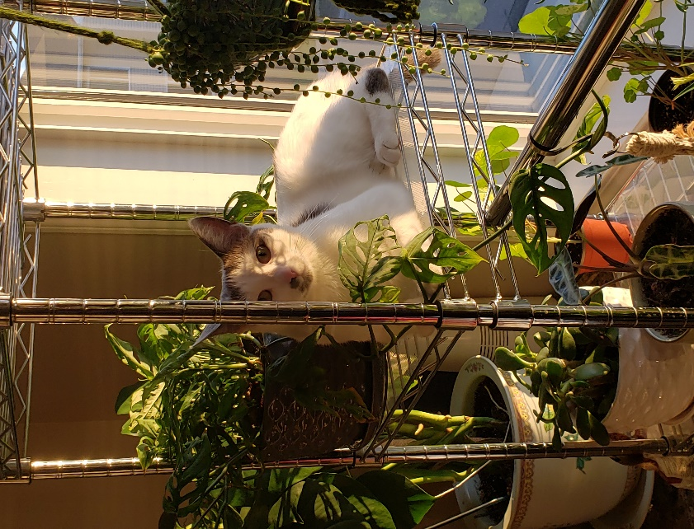

Fertilizer!

**Do you actually need to fertilize?**

**In short YES!! Just like your body needs food to grow, plants need food to grow too. In the case of plants, they need fertilizer especially when it’s the growing season, plants expend a lot of energy growing so a little boost helps out quite a bit!**

|  |  |  |
| --- | --- | --- |
| Fertilizer | Price | How to use! |
|  |  |  |
|  |  |  |
|  |  |  |

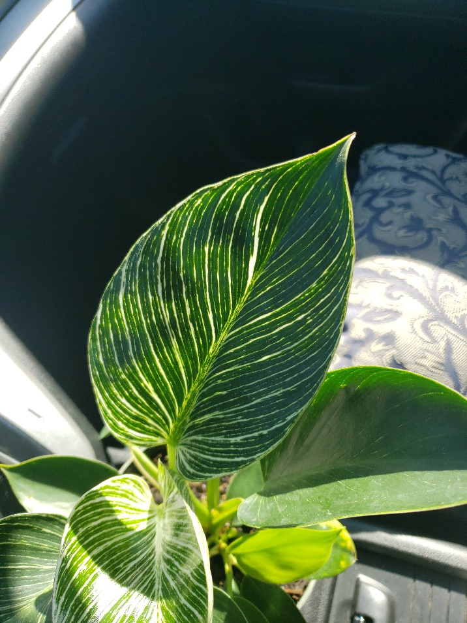

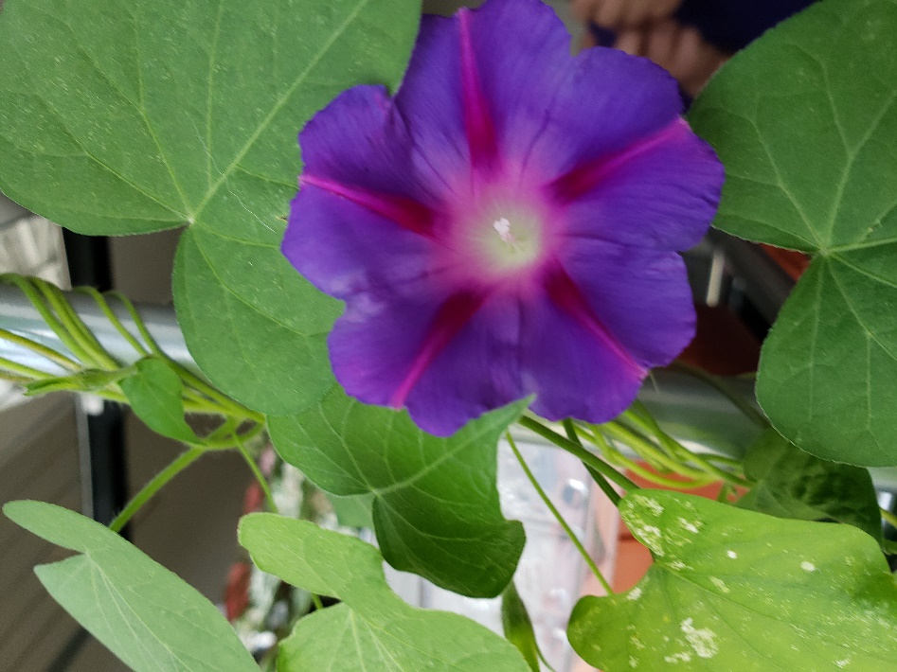

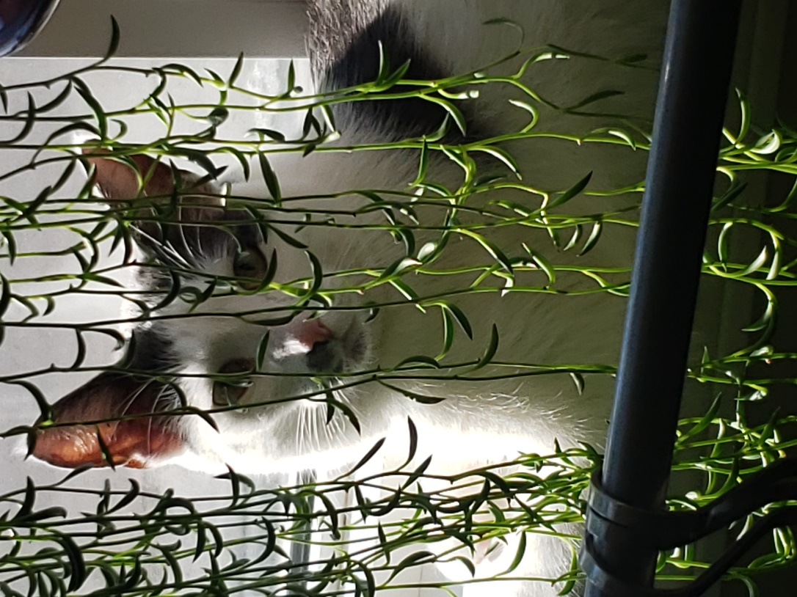

FAQ’s and About us

About us!

|  |  |
| --- | --- |
| Picture | Description |
|  |  |
|  |  |
|  |  |
|  |  |

FAQ

How to order?

Shipping?

Our Guarantee